**Day-3**

What is EC2

* AWS defines it as Elastic Compute Cloud.
* It’s a virtual environment where “you rent” to have your environment created, without purchasing.
* Amazon refers to these virtual machines as Instances.
* Amazon Elastic Compute Cloud (Amazon EC2) provides scalable computing capacity in the Amazon Web Services (AWS) Cloud.
* Using Amazon EC2 eliminates your need to invest in hardware up front, so you can develop and deploy applications faster.
* You can use Amazon EC2 to launch as many or as few virtual servers as you need, configure security and networking, and manage storage.
* Amazon EC2 enables you to scale up or down to handle changes in requirements or spikes in popularity, reducing your need to forecast traffic.
* Virtual computing environments, known as *instances*
* Preconfigured templates for your instances, known as *Amazon Machine Images (AMIs)*, that package the bits you need for your server (including the operating system and additional software).
* Various configurations of CPU, memory, storage, and networking capacity for your instances, known as *instance types.*
* Secure login information for your instances using *key pairs* (AWS stores the public key, and you store the private key in a secure place)
* Storage volumes for temporary data that's deleted when you stop, hibernate, or terminate your instance, known as *instance store volumes*
* Persistent storage volumes for your data using Amazon Elastic Block Store (Amazon EBS), known as *Amazon EBS volumes.*
* Multiple physical locations for your resources, such as instances and Amazon EBS volumes, known as *Regions* and *Availability Zones.*
* A firewall that enables you to specify the protocols, ports, and source IP ranges that can reach your instances using *security groups*
* Static IPv4 addresses for dynamic cloud computing, known as *Elastic IP addresses*
* Metadata, known as *tags*, that you can create and assign to your Amazon EC2 resources
* Virtual networks you can create that are logically isolated from the rest of the AWS Cloud, and that you can optionally connect to your own network, known as *virtual private clouds* (VPCs)

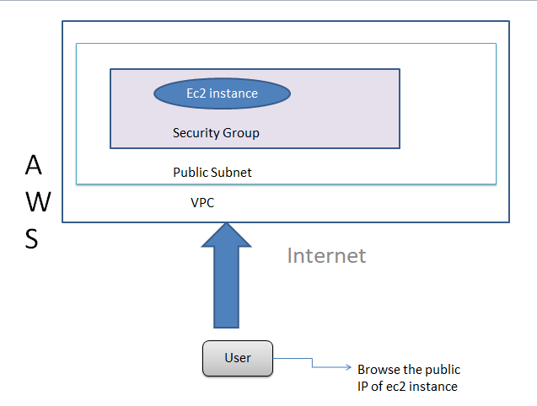

**Spot Instances:**

* Spot Instances are an unused part of Amazon EC2, using which you can save up to 90% on cost as compared to On-Demand cost, but AWS can interrupt your spot instances if the Current Price is higher than the Maximum Price you specified.
* EC2 Spot Instances can be launched the same way you launch EC2 Instance, like using Spot Fleet. Auto Scaling Groups or AWS Management Console.
* If AWS terminates or stops your Amazon EC2 Spot Instance within an hour then you will not be charged.
* However, if you choose to stop or terminate your newly launched Spot Instances by yourself, you will have to pay for the total number of seconds you have used.
* Moreover, you can easily combine Spot Instances with On-Demand, RIs and Savings Plans Instances to further optimize workload cost with performance.
* Due to the operating scale of AWS, Spot Instances can offer the scale and cost savings to run hyper-scale workloads.
* You also have the option to hibernate, stop or terminate your Spot Instances when EC2 reclaims the capacity back with two-minutes of notice.

**Why use Amazon EC2 Spot Instances?**

* Low, predictable price
* Massive scale
* Easy to use

For more information please go to official page , given below.

<https://aws.amazon.com/ec2/spot/?cards.sort-by=item.additionalFields.startDateTime&cards.sort-order=asc&trk=ps_a134p000006vwFfAAI&trkCampaign=acq_paid_search_brand&sc_channel=PS&sc_campaign=acquisition_IN&sc_publisher=Google&sc_category=Cloud%20Computing&sc_country=IN&sc_geo=APAC&sc_outcome=acq&sc_detail=aws%20ec2%20spot%20instances&sc_content=EC2%20Spot_e&sc_matchtype=e&sc_segment=517651795636&sc_medium=ACQ-P|PS-GO|Brand|Desktop|SU|Cloud%20Computing|EC2%20Spot|IN|EN|Text&s_kwcid=AL!4422!3!517651795636!e!!g!!aws%20ec2%20spot%20instances&ef_id=Cj0KCQjw2NyFBhDoARIsAMtHtZ7FOrsKLpm5o0dB794CLQCN155XSDXDx0a0_gW0yKzhWJLJSGA1i3QaAu6rEALw_wcB:G:s&s_kwcid=AL!4422!3!517651795636!e!!g!!aws%20ec2%20spot%20instances>

**Lab 1:**

1. Launching an EC2 Instance
2. SSH into EC2 Instance on putty
3. Install an Apache Server with the help of yum command
4. Create and publish page and check if page is available on public ip
5. Once Validate please terminate the ec2 instance.

**Lab 2:**

Create EC2 Instance and Connect to a windows machine using RDC

1. Log AWS Console.
2. Create an Amazon Windows Instance from Microsoft Windows Server.
3. Go to Ec2 dashboard find your instance in the AWS Management Console.
4. Connect your EC2 Instance using Remote Desktop Connection after getting password.

**Lab 3:**

1. Log into AWS Management Console.
2. Select an Amazon Linux Spot Instance from an Amazon Linux AMI 2.
3. Setting the price of a spot instance to Higher and lower values compared to a given value.
4. Launch the Spot Instance, to understand the difference between higher and lower prices.
5. Test HTML page is launched or not using public IP.